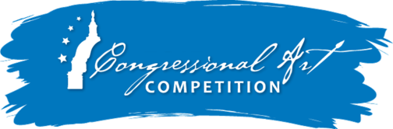
School Confirmation Form

Due no later than April 13, 2021

This form confirms that __________________________________ plans to participate in the
(PRINT HIGH SCHOOL NAME)
40th Congressional Art Competition. To coordinate with Congressman Palmer’s office,

our school’s point of contact is: _________________________________________________.
(PRINT ART TEACHER/COUNSELOR NAME)

Contact’s Phone: _______________________________________________
Contact’s E-mail: _______________________________________________

Contact’s Mailing address: _______________________________________________

_______________________________________________

I understand that the Student Release Form with artwork photo must be submitted to the Congressman’s District Office no later than Tuesday, April 13, 2021. I also understand that no more than five original works of art that comply with contest rules may be submitted from my school.

Signature: ____________________________________________ Date: __________________

Please mail or fax this form to:
U.S. Representative Gary Palmer
Attn: Art Committee
3535 Grandview Parkway, Suite 525
Birmingham, Alabama 35243

Phone: (205) 968-1290 | Fax: (205) 968-1294 | Call for an Email Address

