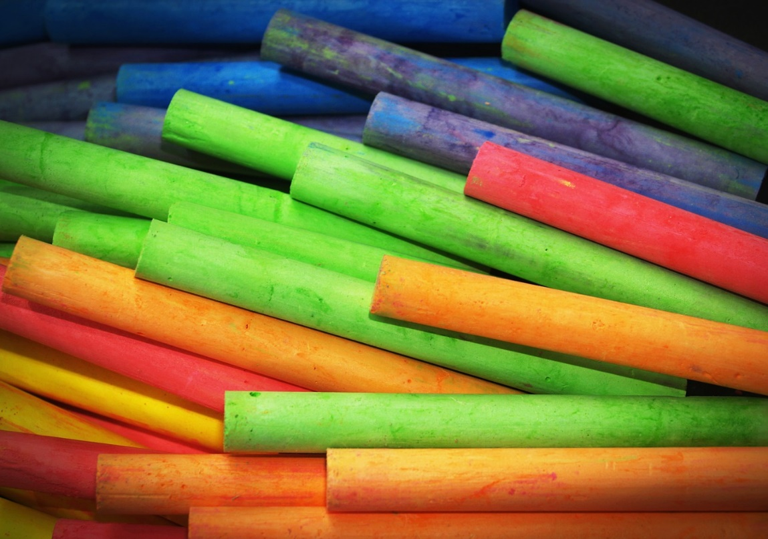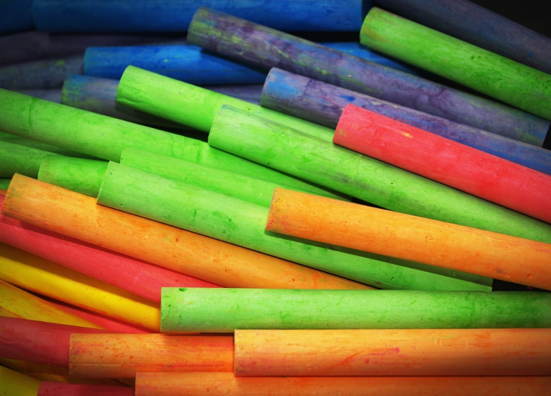

CONGRESSMAN GARY PALMER, AL 06

**2025 CONGRESSIONAL**

**ART COMPETITION**

Competition Guidelines

Photographed Artwork entered in the contest may not exceed 26”X 26” X 4” (including frame if winner). All entries must be an **original** in **concept, design and execution**.

The artwork medium may include the following:

DRAWINGS

pastels, colored pencil, pencil, charcoal, ink, and markers

MIXED MEDIA

PAINTINGS

oil, acrylics, and watercolor

COLLAGE

PRINTS

lithographs, silkscreen, and block prints

Each spring, the Members of the U.S. House of Representatives sponsor a nation-wide high school art competition. The Congressional Art Competition is an opportunity to recognize and encourage artistic talent in the nation, as well as in our congressional district. This competition is open to all high school students in the 6th District. The overall winner of our district’s competition will be displayed for one year in the U.S. Capitol Building. The exhibit in Washington will also include artwork from contest winners nation-wide.

The Congressman works alongside local artists and high schools to collect and display artwork in a **VIRTUAL GALLERY**.

Submission Deadline: **Tuesday, April 22nd**

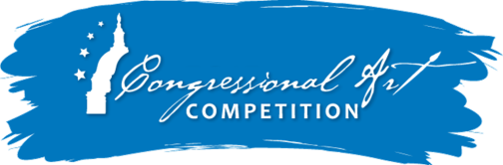High resolution photos of Artwork and entry forms must be submitted to the district office of Congressman Palmer:

Virginia.Amason@mail.house.gov

Questions?Please contact the district office at **205-968-1290**.